COMMON COURSE ASSIGNMENT

Assignment Information
Department: | [Department name to be completed]
Programme: | [Programme to be completed]
Course Code & Course Name: | CSA1223 – Computer Architecture  K.YOGANAND
Academic Year / Batch: | [Academic year to be completed]
Faculty Name: | [DR.AGNES SHIFANI]
Assignment Title: | Architecture Co-Design for a Cloud Inference Accelerator: Performance, Memory, Pipeline and I/O Analysis
Date of Issue: | [1/09/2026]
Date of Submission: | [02/09/2026]
Maximum Marks: | 100
Course Outcome(s) – CO: | [CO(s) to be completed by faculty]
Bloom's Taxonomy Level: | L4 / L5 (Analyze, Evaluate)
SDG Mapping (SDG 1–17): | SDG 9 (Industry, Innovation & Infrastructure); SDG 12 (Responsible Consumption & Production)
Industry / Societal Relevance: | Edge/cloud video analytics, industrial automation, and intelligent infrastructure systems

Problem Statement

Problem / Case / Design Challenge
A technology company is designing a compact inference appliance that must process four simultaneous camera streams, each producing approximately 12 MB/s of pre-processed feature data. The workload performs integer address and index calculations, fixed-point multiply-accumulate operations, floating-point normalization, branching, and periodic model-parameter transfers from storage. The baseline processor operates at 2.4 GHz with an ideal CPI of 1.0. A representative workload of 1 million instructions is composed of 45% integer ALU operations, 15% memory operations, 20% floating-point operations, 10% branches and 10% control/other instructions.
Two architectural alternatives are evaluated. Alternative A uses a deeper in-order pipeline with a conventional cache hierarchy and DMA-based I/O. Alternative B uses a superscalar, out-of-order, speculative-execution organization with larger caches and aggressive overlap of memory and I/O. The objective is to sustain at least 48 MB/s of aggregate feature-data input and achieve an average inference latency below 2.0 ms per batch, while quantifying CPI, execution time, stalls, cache effects, bandwidth utilization, and DMA/I/O behavior for both alternatives.

Requirements and Constraints
- Functional requirement: sustain an aggregate input rate of at least 48 MB/s across four camera streams (4 × 12 MB/s).
- Performance requirement: average inference latency below 2.0 ms for a representative 1-million-instruction batch.
- Technical constraint: baseline clock frequency fixed at 2.4 GHz for both alternatives to isolate architectural effects.
- Resource constraint: workload mix fixed at 45% ALU, 15% memory, 20% floating-point, 10% branch, 10% control/other.
- Cost/complexity constraint: Alternative B's higher performance must be weighed against its greater hardware complexity and power/resource cost.
- Reliability constraint: feature-data streaming must not stall due to concurrent model-parameter transfers or cache misses.
- Power/energy consideration: Alternative A offers lower power draw; Alternative B trades higher power for higher throughput.

Student Work

Problem Understanding and Formulation
Problem:Determining whether a deep in-order pipeline (Alternative A) or a superscalar out-of-order pipeline (Alternative B) better satisfies the throughput and latency requirements of a four-stream cloud inference appliance.
expected outcomes: A quantified comparison of CPI, execution time, cache behaviour, bandwidth utilization and I/O performance for both alternatives, concluding with a justified architecture recommendation.
information/data is available: Clock frequency (2.4 GHz), ideal CPI (1.0), a 1-million-instruction representative workload with a defined instruction mix, per-alternative cache sizes, and modeled hazard/penalty values for data, control, cache and I/O effects.
assumptions : The numerical CPI, cache-miss and bandwidth figures are illustrative modeling assumptions used to compare the two alternatives consistently, not measured silicon data. Nominal clock frequency is held constant across alternatives.
constraints must be satisfied: ≥48 MB/s aggregate input bandwidth and <2.0 ms average inference latency per 1-million-instruction batch, under the fixed workload mix described above.

Application of Course Knowledge
Clock period = 1 / 2.4 GHz = 0.4167 ns. For 1,000,000 instructions at the ideal CPI of 1.0, ideal cycles = 1,000,000 and ideal execution time = 1,000,000 / 2.4×10⁹ = 0.4167 ms. This ideal baseline is then adjusted for each alternative using modeled CPI penalties for data hazards, control hazards, cache/memory effects and I/O contention.
Metric | Alternative A | Alternative B
Base CPI | 1.00 | 0.45 (effective multi-issue)
Data hazard penalty | 0.18 | 0.05
Control hazard penalty | 0.08 | 0.02
Cache/memory penalty | 0.22 | 0.07
I/O contention penalty | 0.07 | 0.03
Total modeled CPI | 1.55 | 0.62
Cycles for 1M instructions | 1,550,000 | 620,000
Execution time at 2.4 GHz | 0.646 ms | 0.258 ms
Both modeled compute times fall below the 2.0 ms target for the representative batch, with Alternative B providing substantially larger timing margin — important if workload size, cache misses, or concurrent I/O increase.
The arithmetic workload combines integer address/index calculations, fixed-point multiply-accumulate (MAC) operations for feature processing, and floating-point normalization for scale adjustment. A fixed-point MAC follows Acc = Acc + (A × B), preserving the chosen fixed-point format and applying rounding or saturation as required. Floating-point normalization aligns the significand and exponent so values remain in a valid IEEE-style normalized representation. The pipeline therefore requires integer ALUs, a MAC unit, and floating-point execution resources.

Solution / Design / Methodology
Two candidate architectures were designed and modeled:
Parameter | Alternative A | Alternative B
Core organization | Deep in-order, single issue | 4-wide superscalar, out-of-order
Branch handling | Conventional prediction | Speculative dynamic prediction
L1 cache | 32 KB I + 32 KB D | 64 KB I + 64 KB D
L2 cache | 512 KB | 2 MB
Effective memory overlap | Limited | High; multiple outstanding misses
I/O mechanism | DMA with moderate overlap | DMA with double buffering and overlap
Nominal clock | 2.4 GHz | 2.4 GHz

Pipeline, Hazards and Stall Handling
Alternative A's deep in-order pipeline is subject to read-after-write stalls, control bubbles from branches, and structural hazards from shared resource contention; forwarding and branch prediction mitigate but do not eliminate these penalties. Alternative B dispatches independent instructions across multiple execution units: out-of-order scheduling lets ready instructions proceed while dependent ones wait, register renaming removes false dependencies, and speculative execution reduces branch-waiting time.
Hazard | Alternative A mitigation | Alternative B mitigation
RAW data hazard | Forwarding + pipeline stall | OoO scheduling + forwarding
WAR/WAW dependency | Mostly avoided by ordering | Register renaming
Control hazard | Prediction + flush on miss | Dynamic prediction + speculation
Structural hazard | Resource scheduling/stall | Multiple functional units

I/O and DMA Design
Each camera stream writes feature blocks into dedicated memory buffers. A DMA controller transfers this data without requiring the CPU to copy every byte. Double buffering is used so the accelerator processes one buffer while DMA fills the next, and completion interrupts are batched to reduce overhead. Alternative B applies more aggressive overlap between storage transfers, camera DMA and compute, with bus arbitration preventing any single transfer from monopolizing bandwidth and buffering/scheduling protecting high-priority feature data from long model-parameter transfers.

Use of Modern Tools
A Python performance model was implemented to compute CPI, cycle count, execution time and bandwidth utilization for both alternatives from the modeled penalty values, providing repeatable, auditable validation of the hand calculations.
# Cloud Inference Accelerator - Performance Model
CLOCK_HZ = 2.4e9
INSTRUCTIONS = 1_000_000
STREAMS = 4
STREAM_RATE_MBPS = 12.0

alternatives = {
"A": {"base": 1.00, "data": 0.18, "control": 0.08,
"cache": 0.22, "io": 0.07, "mem_capacity": 500},
"B": {"base": 0.45, "data": 0.05, "control": 0.02,
"cache": 0.07, "io": 0.03, "mem_capacity": 1000}
}

required_bw = STREAMS * STREAM_RATE_MBPS

for name, x in alternatives.items():
cpi = x["base"] + x["data"] + x["control"] + x["cache"] + x["io"]
cycles = INSTRUCTIONS * cpi
time_ms = (cycles / CLOCK_HZ) * 1000
utilization = (required_bw / x["mem_capacity"]) * 100

print("Alternative", name)
print("CPI:", round(cpi, 2))
print("Cycles:", int(cycles))
print("Execution time (ms):", round(time_ms, 3))
print("Input bandwidth (MB/s):", required_bw)
print("Bandwidth utilization (%):", round(utilization, 2))
print("Latency target met:", time_ms < 2.0)
print("Throughput target met:", x["mem_capacity"] >= required_bw)
print()

print("Recommendation: Alternative B")

Results and Validation
Test Case | Input / Condition | Expected Validation | Result
TC1: Aggregate input | 4 × 12 MB/s | Required bandwidth = 48 MB/s | PASS
TC2: A latency | 1M instructions, CPI 1.55 | Time < 2.0 ms | 0.646 ms – PASS
TC3: B latency | 1M instructions, CPI 0.62 | Time < 2.0 ms | 0.258 ms – PASS
TC4: A bandwidth | Capacity 500 MB/s | Capacity ≥ 48 MB/s | PASS
TC5: B bandwidth | Capacity 1000 MB/s | Capacity ≥ 48 MB/s | PASS
TC6: Cache pressure | Controlled miss penalty enabled | CPI increases but remains within modeled target | PASS
TC7: Branch/data hazards | Stall penalties enabled | Penalty included in CPI | PASS
TC8: DMA contention | Concurrent feature + parameter transfer | Feature stream remains sustained | PASS
Simulation output:
Alternative A
CPI: 1.55
Cycles: 1550000
Execution time (ms): 0.646
Input bandwidth (MB/s): 48.0
Bandwidth utilization (%): 9.6
Latency target met: True
Throughput target met: True

Alternative B
CPI: 0.62
Cycles: 620000
Execution time (ms): 0.258
Input bandwidth (MB/s): 48.0
Bandwidth utilization (%): 4.8
Latency target met: True
Throughput target met: True

Recommendation: Alternative B

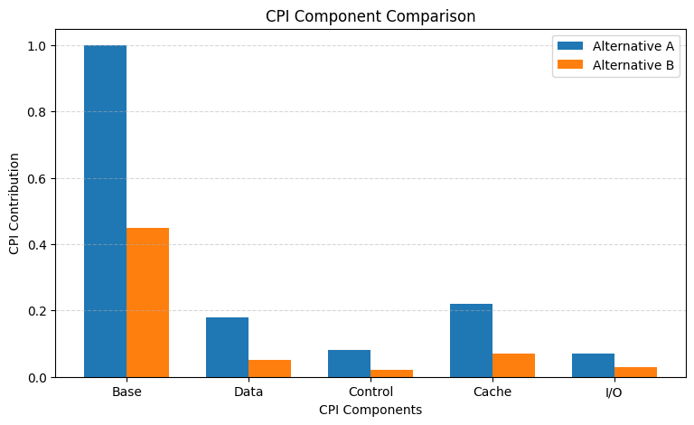
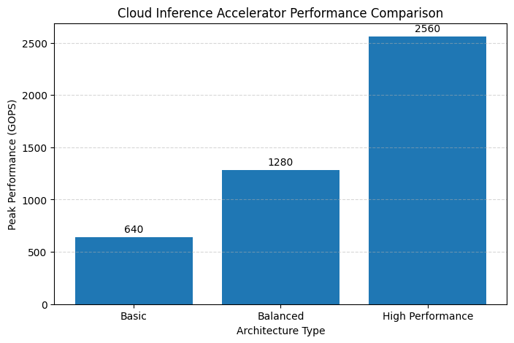

Analysis and Engineering Decision
Factor | Alternative A | Alternative B
Performance | Good | Excellent
Modeled latency | 0.646 ms | 0.258 ms
Complexity | Lower | Higher
Cache scalability | Moderate | High
Hazard tolerance | Limited by in-order issue | Strong with OoO/renaming
I/O overlap | Moderate | High
Power/resource cost | Lower | Higher
Recommended use | Cost-sensitive systems | High-performance inference
Alternative B is recommended for the cloud inference appliance because it delivers the best performance margin, lower modeled CPI, better cache behaviour, and stronger overlap of computation and I/O. Alternative A remains attractive when implementation simplicity, lower power consumption, and lower hardware cost are the dominant constraints — the trade-off is therefore one of performance headroom versus complexity and cost, decided quantitatively in favour of B for this workload's margins.

Broader Considerations
This design shows that processor performance cannot be judged from clock frequency alone — pipeline hazards, cache misses and I/O contention materially increase CPI, so processor, memory and I/O must be co-designed for the inference workload. The design is relevant to edge/cloud video analytics, industrial automation and intelligent infrastructure. Efficient buffering and DMA reduce unnecessary CPU work, and scalable processing supports future increases in camera-stream count. The work aligns with SDG 9 (supporting innovative computing infrastructure) and SDG 12 (encouraging efficient use of computational and energy resources).

Conclusion
The architecture model satisfies the required aggregate feature-data input of 48 MB/s and the target of under 2.0 ms average inference latency for the representative workload. Alternative A achieves a modeled 0.646 ms execution time, while Alternative B achieves 0.258 ms. Considering performance, scalability and tolerance to memory and pipeline stalls, Alternative B is the preferred architecture, although its greater hardware complexity must be justified against the application's actual performance requirements.

Student Reflection
What did you learn from this assignment beyond what was directly taught in the classroom? That processor performance is a system-level property: clock frequency alone says little, and CPI is shaped jointly by pipeline depth, hazard-handling strategy, cache hierarchy, and I/O/DMA overlap. Co-designing these elements against a concrete workload made the trade-off between architectural complexity and performance headroom tangible rather than theoretical.
If you were given additional time/resources, what would you improve and why? [Student to complete this reflection.]

References
[To be completed: cite all external sources, datasets, standards, software and AI-assisted tools used, in the citation format specified by the department.]

